WEEK 1 HANDS_ON
JUnit Testing Exercises
Exercise 1: Setting Up JUnit
package test.java.com;

import org.junit.Test;
import static org.junit.Assert.assertEquals;

public class CalculatorTest {
@Test
public void testAddition() {
int result = 2 + 3;
assertEquals(5, result);
}
}
OUTPUT:
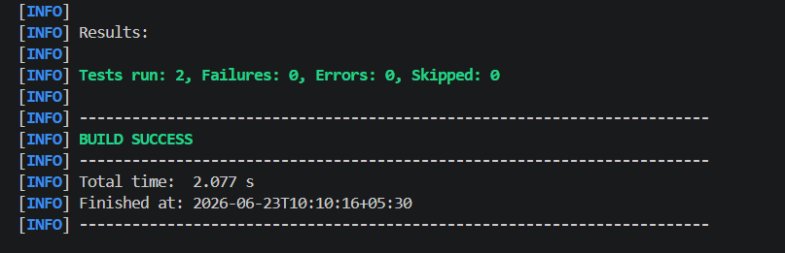

Exercise 3: Assertions in Junit
package com.example;

import org.junit.Test;
import static org.junit.Assert.assertThrows;

public class ExceptionTest {
@Test
public void testException() {
// Using assertThrows to check for ArithmeticException
assertThrows(ArithmeticException.class, () -> {
int result = 10 / 0; // division by zero
});
}
}

OUTPUT: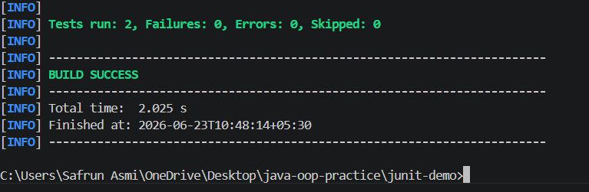

Exercise 4: Arrange-Act-Assert (AAA) Pattern, Test Fixtures, Setup and Teardown Methods in Junit
package com.example;

import org.junit.Before;
import org.junit.After;
import org.junit.Test;
import static org.junit.Assert.assertEquals;

public class CalculatorAAATest {
private int value;

@Before
public void setUp() {
// Arrange: initialize test data
value = 10;
}

@After
public void tearDown() {
// Cleanup after each test
value = 0;
}

@Test
public void testAddition() {
// Act
int result = value + 5;

// Assert
assertEquals(15, result);
}

@Test
public void testMultiplication() {
// Act
int result = value * 2;

// Assert
assertEquals(20, result);
}
}
OUTPUT: